Phase 01B - Bot Technical Specification

**System Overview:**

Figure1 details the overall layout for the bot. Two 9 volt batteries and a series of coin cell batteries (totaling 6 volts) interface with a drive/power circuit via housing (for easy access/replacement). These batteries connect to a conditioning/isolation circuit which separates three power nets (1 for the digital logic, 2 for the analog signal conditioners, and 3 for the motor drive system). These power nets then interface via header pins to a pin breakout which is shown above to plug directly into the Arduino. One benefit of this plug-and-play design is the ability for users to program/debug and prototype various modules with ease.

This pin breakout board connects drive/power nets with the Arduino. Additionally, it connects LEDs, sensing systems, and communication hardware to the Arduino. All of these circuits are mounted in an insulating housing. The Arduino connects to this housing via mounting screws, and multiple button cutouts are implemented within the housing such that a collision detection system may surround the entire bot.

Below this housing, two electric motors are attached via glue (and/or proper mechanical means) such that two back wheels can actuate the bot. Two front wheels interface via a freely-rotating fixed angle common axle to allow the bot to maintain proper balance and freedom of movement. The distance between front and back wheels in relation to the distance between respective side wheels are calculated to optimize the bot turning capabilities for high-precision movement. The bot rotates via software control of the drive system (in which both motors are controlled independently). Each module is detailed below.

**Drive System:**

We will use an NMOS transistor to control the each of the motors.  The transistor will act as a switch between the motors and their designated power supply.  A PWM output from the Arduino will be attached to the gate of the transistor.  We will alter the speed of the wheel by altering the duty cycle of the PWM output.  We will use a frequency of the PWM that optimizes power usage.

**Collision System:**

The collision system is responsible for detecting when the bot has run into something.  It is also responsible for communicating where the collision occurred.  Collisions will be detected through the compression of buttons.  We anticipate gluing bumper panels (long strips of poster board) onto groups of buttons to “fill in” the possible locations for collisions.  The buttons will stick through the housing of the bot, and these bumper panels will be glued onto the buttons.  There will be one panel glued to every two buttons.  There will be three panels at the front of the bot (at various angles), and one panel at the back of the bot.  This means that there are four total panel groups (locations for possible collisions), with eight total buttons.  The collision system will communicate whenever there is a collision (a button is pressed down) in each panel.

**Sensing System:**

The bot will have a landmine detection system consisting of the Hall Effect sensor (Micronas HAL 115) which will be used to detect the south pole of a magnetic field, and corresponding software which uses the Hall voltage produced by the sensor to recognize the presence of a landmine.

The bot will also have a photoreflective sensor sub-system which will be able to differentiate between a reflective piece of colored paper (blue or red) and a black ground plane located beneath the bot. The subsystem will use the BPV22NF Silicon PIN Photodiode, and the Panasonic NaPiCa sensor, which has a photocurrent proportional to illumination with a linear output corresponding software will use the produced current to determine whether the bot is over the desired path and accordingly move to remain above the colored path.

Finally, the bot will need an ultrasound communication subsystem, consisting of a microphone (CMA 4544PF-W) and a speaker (CLS 0201MA-L152). The system will operate at a carrier frequency of 18.75 kHz with a designated protocol at dedicated frequencies of 200 Hz, 300 Hz, and 400 Hz. The protocol will conform to a short, countable sequence specification which will be defined. The bot will communicate at the start at 200 Hz with Command Center to begin the search. It will communicate at the landmine location when found at 300 Hz with Command Center to indicate that the landmine was found. Finally it will communicate at 400 Hz after touching the wall at the end of the red or blue path to either start the second bot, or have the second bot signal the end of the acceptance test.

**Deliverables:**

We plan to work according to the assignment due date listing posted on Trunk. The general layout for this timeline is as follows:

1. Motor Control – Complete design by 2/8
   1. How do we drive motors to go forwards, backwards, variable speeds, etc. etc.
   2. How do we ensure these motors don’t inject voltage spikes into our precious Arduino?
   3. How do we drive these motors with a separate power net so that we don’t compromise battery life?
2. Motion Control – Complete design by 2/11
   1. Ok, now that we can control our motors, how do we use them to move properly?
   2. How do we turn left at 45 degrees?
   3. How do we reverse in a straight line?
3. Sensor Measurements – Complete design by 2/25
   1. How do we detect magnets
   2. How do we detect sound signals?
   3. How do we emit sound signals?
   4. How do we detect infrared light and determine from this whether or not we are on top of the line?
4. Collision Detection Spec/Accepted – 2/25
   1. How do we process collision?
5. Outsourcing Collision-Detection Delivery – 3/15
6. Final Project – 4/26

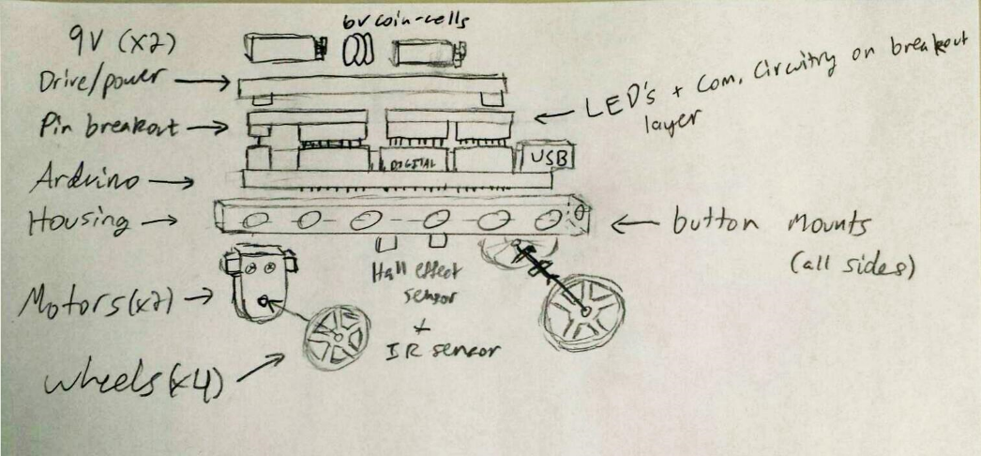

Figure - Sideview of V1.0 of a Bot

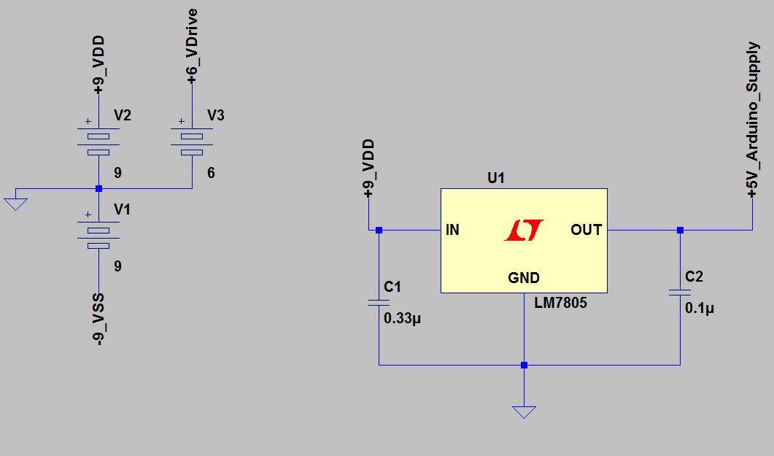

Figure - Voltage Regulation schematic